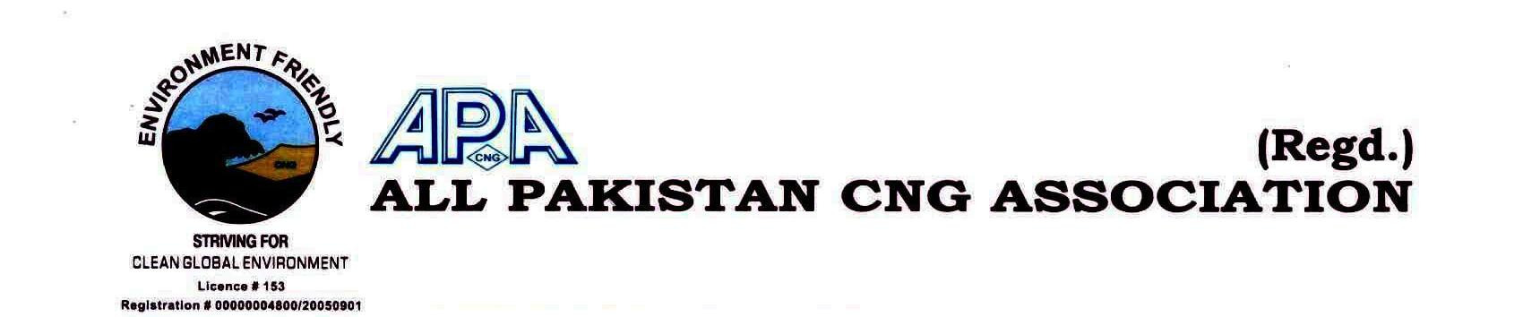

MEMBERSHIP FORM FY 2024-25

Ref:…………………………….. Date:……………………….…………

Name of CNG Station (in OGRA):…………………………………………………………………………………………………………………………..……….

Company Representative for Membership……………………………………………………………………………..……………………………………..

CNIC # ………………………………………………………..Mobile#:………………….………………….. Email id:…..……………………………………………

CNG Station’s Address: ………………………………………………………..………………………………………………………………………….…….………

CNG Station’s Phone#:….…………………………………Fax#:………..………….………… Company Office Phone#................................

Company’s Office Address/Postal Address (if any):……………..…………………………………………………………………………………………

Business Details: (a)- Sole Proprietorship (b)-Partnership (c)-Pvt ltd Company

OGRA License#:……………………………………………………..SNGPL/SSGC Consumer/Account ID:…..………………….…………..…………….

NTN# of Station/Company:……………………………..……………….. GST Reg# ……………………….…..………………………..…………………….

No. of Compressor/s…………………………….. (1).Make/Model:…………..……………………… (2). Make/Model:………...…………………

Capacity Hm3:……………..………Storage Capacity ……..……………………………..No. of Dispensers:…………..Make:……………………….

**UNDERTAKING**

I…………………..……………………………S/o…………………….………………..R/o…………….……………………………….…………………………………….

Proprietor/Owner/Partner of……………………………………………………………………….do hereby affirm & declare that I have gone through the terms and conditions to be the member of All Pakistan CNG Association and hereby affirm my commitments to be the bonafide member of the association. The interest of the Association will be my paramount consideration in all the affairs & proceedings of the Association Business.

………………………………… …………………………………

Signature CNG Station’s Stamp

_________________________________________________________________________

**Central Office:** 401, 4th Floor, Ayan Plaza, Service Road East, Garden Town, Islamabad Expressway, Islamabad.

**Ph:** 0321-5949822 **Email:** [apcnga@gmail.com](mailto:apcnga@gmail.com), **WEB:** www.apcngassociation.com