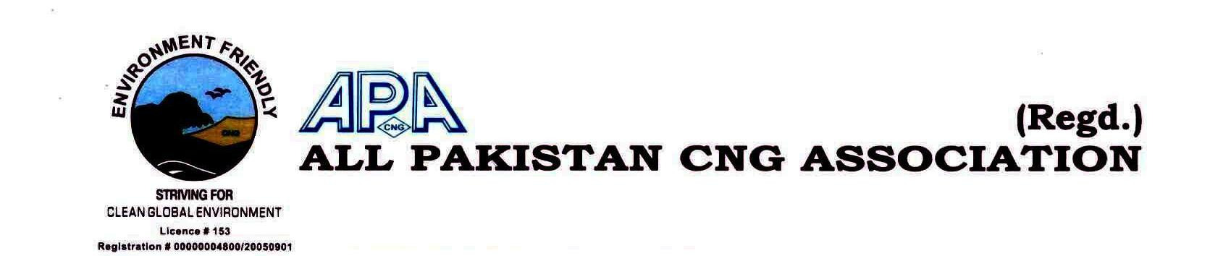
MEMBERSHIP FORM 2019-20
Ref:…………………………….. Date:……………………….…………
Name of CNG Station:…………………………………………………………………………………………………………………………………………..……….
Company Representative: …………………………………………………………………………..Mobile#:………………………………………………..
CNG Station’s Address: ………………………………………………………………………………………………………………………………….…….………
CNG Station Phone#:…………………………………Fax#:……………….………… Email Address:…………………………………………………….
Postal Address (If any): …………………………………………………………………………………………………………………………..…………………….
Business Details: (a)- Sole Proprietorship (b)-Partnership (c)-Pvt ltd Company
OGRA License#:……………………………………………………..SNGPL/SSGC Consumer/Account ID:…..………………………..…………….
NTN#:……………..……….. GST Reg# :………….……..……………………. No. of Compressor:……………. Make:…………..……………..…
Capacity Hm³:……………..………………Storage Capacity Hm³:……..………………………No. of Dispensers:…………..………………….

…………………………………
CNG Station Stamp

I…………………..…………………………S/o…………………….………………..R/o…………………………………….…………………………………….
Proprietor of……………………………………………………….do hereby affirm & declare that I have gone through the overleaf terms and conditions to be the member of All Pakistan CNG Association and hereby affirm my commitments to be the bonafide member of the association. The interest of the Association will be my paramount consideration in all the affairs & proceeding of the Association Business.

…………………………………
Signature

_________________________________________________________________________
Central Office: 401, 4th Floor, Ayan Plaza, Service Road East, Main Expressway, Islamabad.
Ph: 0321-5949822, Fax: 051-2617511, Email: apcnga@gmail.com, WEB: www.apcngassociation.com

